# LDR (Light Dependent Resistor)

An LDR or photoresistor is a light-sensitive component whose resistance decreases with increasing light intensity.

**Working Principle:**Made from semiconductors, the LDR’s resistance changes as light photons hit it, altering the current flowing in a circuit.

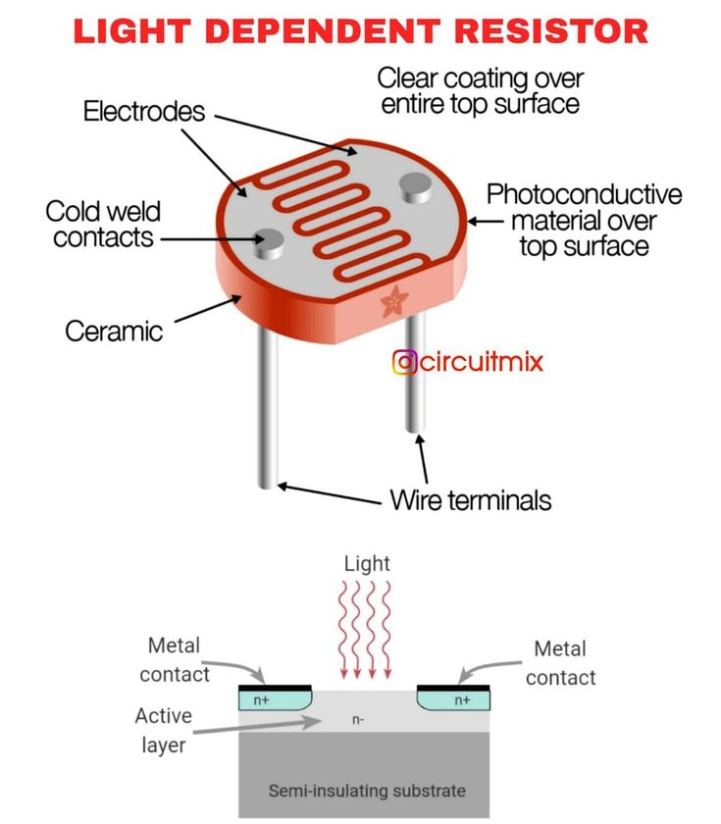**Types**:  
- Cadmium Sulfide (CdS) LDRs  
- Lead Sulfide (PbS) LDRs

**Applications**:  
- Light meters  
- Automatic street lights  
- Alarm systems   
- Solar trackers

**Advantages**:  
- Simple and inexpensive  
- Passive component (no power needed to operate)

**Disadvantages**:  
- Slow response time  
- Affected by temperature